Name : VED KHODE PRN : 25070521176
5.1.2] Student Grade based on Aggregate
ALGORITHM
Step 1: Start the program.
Step 2: Input marks of four subjects: m1, m2, m3, m4.
Step 3: Calculate the total marks using:
total = m1 + m2 + m3 + m4
Step 4: Calculate the aggregate percentage using:
aggregate = (total / 400) × 100
Step 5: Check the aggregate percentage:
If aggregate > 75, assign grade = Distinction
Step 6: Else if aggregate ≥ 60 and < 75, assign grade = First Division
Step 7: Else if aggregate ≥ 50 and < 60, assign grade = Second Division
Step 8: Else if aggregate ≥ 40 and < 50, assign grade = Third Division
Step 9: Else, assign grade = Fail
Step 10: Display the total marks.
Step 11: Display the aggregate percentage up to two decimal places.
Step 12: Display the grade of the student.
Step 13: End the program.
PYTHON CODE
m1, m2, m3, m4 = map(int, input().split())
total = m1 + m2 + m3 + m4
aggregate = (total / 400) * 100
if aggregate > 75:
grade = "Distinction"
elif aggregate >= 60:
grade = "First Division"
elif aggregate >= 50:
grade = "Second Division"
elif aggregate >= 40:
grade = "Third Division"
else:
grade = "Fail"
print(total)
print(f"{aggregate:.2f}")
print(grade)
FLOWCHART
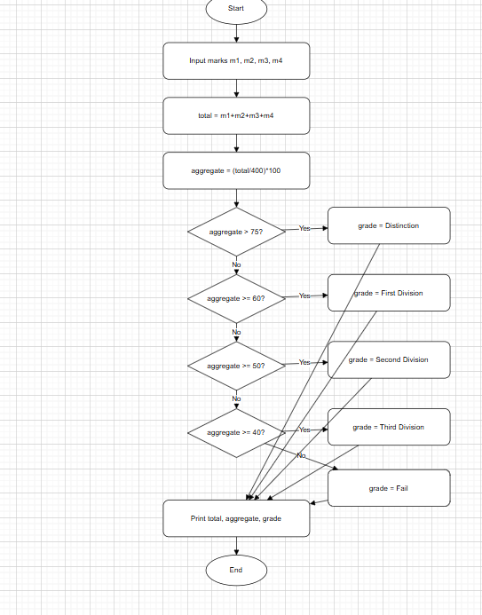

EXCECUTION
